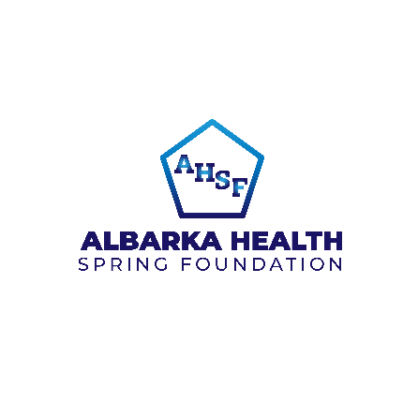
Request for Quotation (RFQ) forSupply of Delivery Kit at ALBARKA HEALTH SPRING FOUNDATION(AHSF)

RFQ Number:ASHF/NHF/25675/0035.
Request for Quotation (RFQ) for the Supply of Delivery Kit.
S/N | Description | Unit | Quantity
1 | Dettol Liquid 165ml | pcs | 700
2 | Bar of multipurpose soap, 100mg | pcs | 700
3 | Goya Olive Oil | Pcs | 700
4 | Polyethene plastic bags, 18X28CM | Pcs | 700
5 | Clear plastic sheet (mackintosh),100cm X 100cm | Pcs | 700
6 | Plastic Apron | Pcs | 700
7 | Disposable Razor blade, single -edge, | Pcs | 700
8 | Umbilical tape, 3mm X15cm (Cord Clamp) | Pcs | 2100
9 | Cotton wool 1 roll | Pcs | 700
10 | Surgical Gloves, Medium, Single use | Pcs | 1400
11 | Tetracycline hydrochloride eye ointment 1%, tube, 5g | Pcs | 700
12 | Misoprostol tabs 1 pack x 4 | pack | 700
13 | 7.1% Chlorhexidine digluconate,aquous solution or gel, delivering 4% chlorhexidine | Pcs | 700
14 | Mucus extractor | Pcs | 700
15 | Sanitary towels | pack | 1400
16 | Baby Blanket | Pcs | 700
17 | Baby sweater with hood | Pcs | 700
18 | Johnson Baby bathing soap 100g | Bar | 1400
19 | packing bag- (Ghana must go), Small size, to kit up the items | pcs | 700
20 | Reusable pad | pcs | 700
21 | Transportation Cost | Lump sum | 1

