ROLE PROFILE

|  |  |  |  |
| --- | --- | --- | --- |
| Title: | Deployment Manager | | |
| Functional Area: | Delivery, Performance & Accountability Group | | |
| Reports to: | Head of Performance – Insights, Planning & Reporting | | |
| Location: | Global Hub – but postholder can be based in any Plan International location. | Travel required: | Rare |
| Effective Date: 02/05/2023 |  | Grade: | GH 4 |

role PURPOSE

Plan International is an independent child rights and humanitarian organisation committed to children living a life free of poverty, violence and injustice.

We actively unite children, communities and other people who share our mission to make positive lasting changes in children’s and young people’s lives. We support children to gain the skills, knowledge and confidence they need to claim their rights to a fulfilling life, today and in the future. We place a specific focus on girls and women, who are most often left behind.

We have been building powerful partnerships for children for more than 85 years, and are now active in over 80 countries.

From time-to-time Plan International Country Offices require expertise in a specific area – perhaps deep technical expertise to develop a new project, support in improving grants management or OD support for a complex change project. There is also a requirement to identify and deploy people quickly when an emergency occurs.

Plan International is developing a more coordinated approach to how it provides short-term support to country offices, aiming to harness the knowledge, skills and experience of our global network in a more efficient and effective way. A new role of Deployment Manager has been created to co-ordinate this support, including managing the DRM roster for emergencies.

The postholder will identify country office resource requirements, create a single resourcing plan and manage the implementation of the plan, including optimising staff utilisation, managing the recharging process and communicating the schedule to staff, so each team member knows exactly what they are working on and when.

The model below summarises Plan International’s workforce planning objective and the workforce planning journey we are embarking upon. Ultimately, the aim is to use a workforce scheduling system – either an HRIS module or a module linked to HRIS - to simplify the process. The postholder will also lead the project to identify and implement the scheduling software

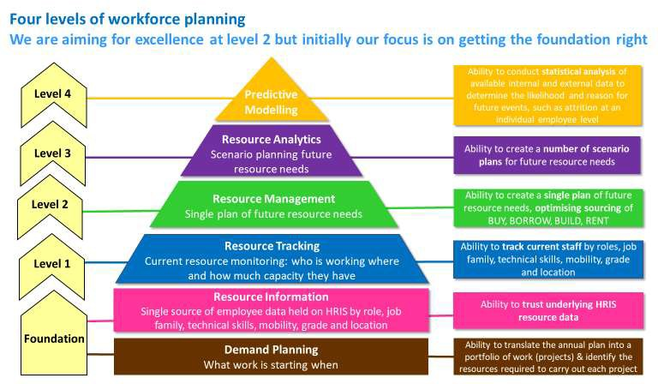

Dimensions of the Role

**Budget held**:

**Number of direct reports**: none

**Locations**: anywhere where Plan has an office. Largely desk based but will require frequent interaction with individuals and teams from around the organisation.

Expected to work outside standard office hours at short notice for business-critical needs, particularly in response to sudden onset emergencies

**Main challenges of the role**

* Making the time to maintain good relationship with a diverse group of stakeholders
* Able to understand the complexity of Plan’s structure and decision-making processes and work effectively to deliver the results
* Being adaptable, flexible and able to respond quickly to changing needs
* To lead on embedding resource planning and use of resource management systems as a core organisational capability

Accountabilities

1. **Identifying demand:** developing and implementing a simple process that enables country offices to request short term support. Working with clients to manage expectations and to ensure each CO’s resource demands are fully understood.

2. **Building a database:** using HRIS information to build a database of deployable staff (both from Plan International and externally) and recording their specialty areas, knowledge, skills & expertise, together with the % of time they are available for deployment. This may include liaising with colleagues across all entities (NOs, COs, Regional and Global Hubs) to identify additional people who are available for deployment, if skills are not available within the current resourcing pool.

3. **Creating a resourcing plan:** allocating resources when a project is confirmed or when the right resource against a project is identified, based on individuals’ expertise, skills, previous experience or availability.

4. **Resource analytics and modelling:** modelling different demand scenarios in order to predict resource availability for future projects to ensure there is enough capacity to deliver upcoming projects and working with team leaders to identify additional staff, where required.

5. **Managing the plan:**

• Proactively monitoring the resourcing plan, by managing staff utilisation levels, identifying and resolving over-allocation on projects and ensuring an even spread of work allocation for all staff across the organisation for example by looking out for employee over- utilisation, uneven workload or additional hours being worked

• Re-allocating resources as required - for example, by adjusting goals or requirements or assigning new people to the project or shuffling resources as new projects and opportunities arise.

• Knowing the requirements of each project and making recommendations to hire new people or call on external resources, as needed.

6. **Managing recharging and pricing:** working with HR and finance, ensure cost of resources allocated to COs are recharged where appropriate. This includes visibility on cost and liaising with finance and HR functions to ensure the recharge process is carried out.

7. Ensures that Plan International’s global policies for Safeguarding Children and Young People and Gender Equality and Inclusion are fully embedded in accordance with the principles and requirements of the policy including relevant Implementation Standards and Guidelines as applicable to their area of responsibility. This includes, but is not limited to, ensuring staff and associates are aware of and understand their responsibilities under these policies and Plan International’s Code of Conduct (CoC), their relevance to their area of work, and that concerns are reported and managed in accordance with the appropriate procedures

Key relationships

* Regional and country directors and their deputies
* Global Hub heads of function, particularly Humanitarian Director
* HR and finance teams

Technical expertise, skills and knowledge

**Essential**

* Experience of DRM roster management and / or resource management in a global organisation at management level, and of driving innovations or improvements
* Experience of statistical modelling and analysis, and of using analysis to derive insights and drive decisions and actions
* Experience of navigating organizational complexity, including structures and decision-making processes, and of influencing others to deliver results
* Strong project management experience
* Knowledge of the INGO environment, ideally in relation to both humanitarian and development contexts.
* Ideally, experience of working in the global south
* Superb interpersonal skills - the ability to collaborate with teams both inside and outside the organisation and to build trust across different cultures and geographies.
* Strong financial understanding and budget management.
* Understanding of the use of IT systems in DRM roster management / resource management, and the ability to work with IT specialists on system development/ enhancements
* Be humble, appreciative and solutions orientated.
* Models Plan International’s values, behaviours and feminist leadership principles
* Strong rational and emotional intelligence, with resilience in the face of pushback and resistance to new ideas and ways of doing things.
* Ideally, proficient in a language or languages other than English – especially French, Spanish, Arabic.

Plan International’s Values in Practice

**We are open and accountable**

We create a climate of trust inside and outside the organisation by being open, honest and transparent. We hold ourselves and others to account for the decisions we make and for our impact on others, while doing what we say we will do.

**We strive for lasting impact**

We strive to achieve significant and lasting impact on the lives of children and young people, and to secure equality for girls. We challenge ourselves to be bold, courageous, responsive, focused and innovative.

**We work well together**

We succeed by working effectively with others, inside and outside the organisation, including our sponsors and donors. We actively support our colleagues, helping them to achieve their goals. We come together to create and implement solutions in our teams, across Plan International, with children, girls, young people, communities and our partners.

**We are inclusive and empowering**

We respect all people, appreciate differences and challenge inequality in our programmes and our workplace. We support children, girls and young people to increase their confidence and to change their own lives. We empower our staff to give their best and develop their potential.

Physical EnvironmenT

This role can be based in any Plan International location

Level of contact with children

Low contact: No contact or very low frequency of interaction