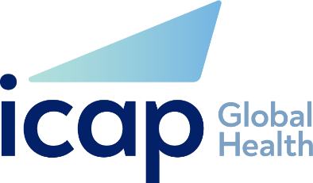

ICAP at Columbia University
Job Description
Job Title: | Quality Improvement & Innovation Officer
Reports To (Title): | Quality Improvement & Innovation Advisor
Incumbent: | N/A
Location: | Abuja, Nigeria
Date: | December 2022

POSITION SUMMARY:
Working under the supervision of the Quality Improvement Advisor, ICAP in Nigeria, the Quality Improvement (QI) Officer will drive the frontline implementation of Quality Improvement capacity-building interventions in ICAP-supported States within Nigeria. S/he will execute capacity-building activities relating to training, coaching, implementation, and supportive supervision for the QI project and the evaluation of QI initiatives at State, Local Governments, and Sites levels, in collaboration with relevant Stakeholders and ICAP implementation partners.

MAJOR ACCOUNTABILITIES:
The Quality Improvement Officer will:
- Be responsible for day-to-day monitoring and evaluation of QI initiatives in ICAP-supported sites through active collaboration with the designated technical focal persons in supported States, Local Government Areas (LGAs) and facilities.
- Deliver face-to-face and virtual training and workshops sessions, on-site QI coaching and contribute to evaluating training sessions, workshops, webinars, and other training projects.
- Build the capacity of the Health care workers (HCWs) and other relevant QI stakeholders within the supported States in establishing structures for delivering QI activities at the facility, LGA and state level; including QI management systems, QI teams, QI meetings, QI champions and QI dashboards or bulletins for relevant audiences.
- Coach HCWs to institutionalize and routinely update paper and digital dashboards to visualize outputs and outcomes of QI projects initiated to optimize program performance at the facility level.
- Support site-level QI assessments, projects and collaboratives including patient satisfaction surveys.
- Track the availability and routine use of QI-related tools and charts in supported facilities.
- Collate, analyze and report on outcome-level data to help determine the project’s impact on patient’s clinical outcomes and quality of life.
- Document training and technical assistance activities and contribute to the production and dissemination of technical reports, guides, manuals, success stories, and other printed resources and toolkits.
- Routinely attend appropriate program review meetings; executing resolutions within her/his purview.
- Carry out any other QI-related tasks as may be assigned by the Quality Improvement and Innovation Advisor.

EDUCATION:
- An advanced university degree (MBBS, RN, MPH) in Medicine, Nursing, Public Health, or a related field.
EXPERIENCE, SKILLS & MINIMUM REQUIRED QUALIFICATIONS:
- Minimum of 3 years of relevant experience and demonstrated expertise in the implementation of relevant HIV and QI program activities
- Experience participating in quality improvement projects using the Model for Improvement or similar methods is preferred.
- Familiarity with PEPFAR and Government of Nigeria standards for QI in HIV programs.
- Demonstrated computer skills, including proficiency with MS Word, PowerPoint, and Excel are required.
- Ability to work independently with strong problem-solving skills
- Fluent English oral and written communication skills; and ability to interact professionally in English.
TRAVEL REQUIREMENTS:
- Travel within assigned state supporting capacity building, building facility QI systems, stakeholder relationship management and implementing QI activities.

