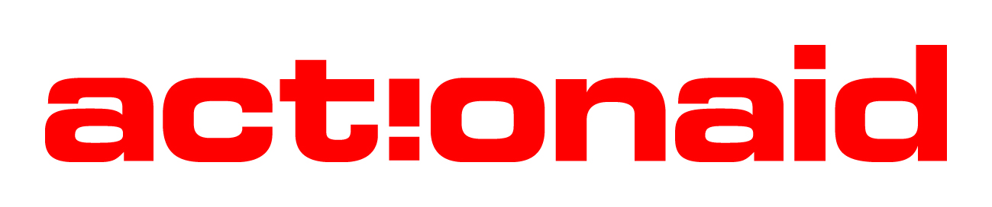

JOB DESCRIPTION

Job Title: Communications Intern

Location: Abuja, Nigeria

Reporting to: Communications Coordinator

Line Management: None

Summary
The Intern position is an opportunity offered by ActionAid Nigeria (AAN) for young graduates to earn a post NYSC experience. It is therefore both a learning and value-adding relationship between interns and AAN. The intern is expected to take advantage of the space offered for experience gathering, self-development, while providing quality service to ActionAid Nigeria.

Job Purpose
The Communications Intern will be responsible for assigned communications roles including supporting the execution of the organisation’s communications strategy, social media strategy, managing organisation’s prioritised social media channels - including Facebook, Twitter, Instagram, Youtube and LinkedIn. S/he will liaise with the Communications Coordinator in providing support for the different thematic functions at AAN on publications, social media, publicity & press relations to drive the advocacy arm of AAN.
Person Specifications
- Support Campaigns and Communications activities
- Provide support and participate in campaign activities directly handled in the unit
- Provide support and participate in all inter-thematic policy advocacy and campaign initiatives
- Provide support and participate in monitoring, documentation, dissemination and encouragement of critical debate, and mainstreaming of public policy advocacy.
- Support case study collections related to policy and campaigns works

- Social Media Community Management
- Work on the organisation’s social media platforms
- Work with the Communications Coordinator on all AAN online activities
- Work on seamless linkages of the organisation’s social media accounts (e.g. Facebook, Twitter, YouTube LinkedIn and other social media platforms), ensuring uniform content and tone of voice for landing pages, graphics, and other elements
- Monitoring and replying to communications on the platforms under the guidance of Communications Coordinator.
- Posting information, uploading photos and videos on the platforms daily or as is directed by Communications Coordinator.
- Make use of relevant tools like Tweet Deck to plan for weekends and holidays; LinkedIn polls and surveys to build our social media footprint and reputation; and other tools like SlideShare, YouTube, Paper. Li, Scribd, Reddit, Digg and StumbleUpon.
- Work with relevant teams and projects’ leads to implement other channel-specific campaigns (e.g. uploading photos to Flickr, videos to YouTube, etc)
- Perform any other assigned responsibilities as it relates to the Communications hub and implementation of AAN Communications Strategy

- Key relationships
- Internal Relationships: Entire AAN staff
- External Relationships: Media, Communications Consultants/service providers, CSOs, relevant Government agencies and partners

Persons Specifications
Attributes/Skills | Essential | Desirable
Education/  Qualifications | - First degree in Mass Communication or any relevant field. | - Membership of relevant professional Institute
Experience | - Relevant NYSC experience in the related fields is essential.  - Knowledge of the social media platforms  - Content production; video, graphics design and photography experience is essential | - Experience working in Digital and Mainstream Media sector is desirable
Skills/ Abilities | - Strong communication and writing skills  - Good computer skills especially in the use of publishing tools  - Multi-tasking skills is essential  - Excellent planning and prioritization skills is essential | - Content production/Photography skills
Personal Qualities | - A person of integrity  - Creative and takes initiative.  - Able to work effectively in a diverse team environment  - Willing to work additional hours at crucial times  - Effectively promote the AAN’s mission, values and objectives

Signed by: _______________________________________________
Communications Intern

Signed by: _______________________________________________
Communications Coordinator

