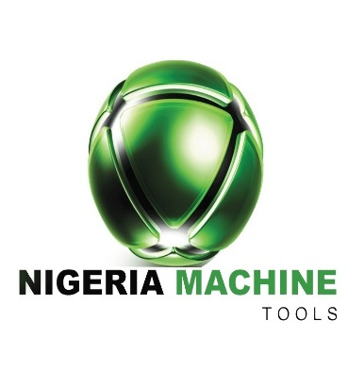

**INTERNAL MEMO**

TO: ABDULFATAI ABDULLAZIZ TAIWO

DEPT/SECTION: NMT Protective Solutions

FROM: HR/Admin Officer

DATE: 7/02/2020

**QUERY**

You are to explain in writing, before the close of work today why disciplinary actions should not be taken against your disobedience and unruly behaviour to your line manager at the pre-start meeting today.

Kindly explain your actions.

Sincerely yours,

......................

**FOR: NIGERIA MACHINE TOOLS LIMITED**

**‘Etoloh Harold**

Human Resources & Admin Officer

Cc: Gompang James