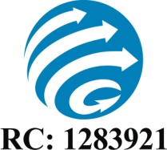

Plot 105, Ebitu Ukiwe Street, Jabi, Abuja - FCT, Nigeria.

+234 (0)817196 66666, +234 (0)817 8766666

**TONGYI NEW INTERNATIONAL CONSTRUCTION LTD**