ZEANI COMMUNITY DEVELOPMENT SERVICE EDUCATION (CDSE) PROGRAMME
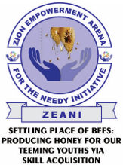
Non-Profit Institution (NPI) /Non-Governmental Organization (NGO)

